**AI Sentinel: Transformative Deep Learning Technologies for Next-Gen Driver Vigilance in Revolutionizing Road Safety**

**A Project Work Synopsis**

*Submitted in the partial fulfilment for the award of the degree of*

**BACHELOR OF ENGINEERING**

**IN**

**COMPUTER SCIENCE WITH SPECIALIZATION IN**

**ARTIFICIAL INTELLIGENCE AND MACHINE LEARNING**

**Submitted by:**

21BCS8441 – HARI OM SINGH

21BCS8572 – VIVEK KUMAR

21BCS8942 – PRANAB SHARMA

21BCS10625 – HIMANSH RAJPUT

**Under the Supervision of:**

**Mrs. PRIYANKA KAUSHIK**



**CHANDIGARH UNIVERSITY, GHARUAN, MOHALI - 140413,**

**PUNJAB**

**April, 2024**

# Abstract

In the vehicle security system we recognize the driver’s face and give alerts whenever the driver is drowsy and he blinks his eyes and an alarm is ringed to maintain their safety. Drowsiness is one the main reasons/ major causes these days for road accidents. Here, to avoid such kind of accidents we’re developing a system which is a drowsiness alert system and vehicle’s safety system. By using Artificial Intelligence (AI) technology, we’re building this system. Firstly, the image of the driver is captured and it is identified by using face recognition techniques and once the driver is in the vehicle and he starts driving the vehicle, for instance if he feels drowsy there will be an alert/ alarm so that he can get himself awake, take a break and then drive the vehicle.

Computer vision and machine learning algorithms are used to design this system. In this system, we’re using eye landmarks which determine the EAR (Eye Aspect Ratio ratio) to check whether the driver is drowsy. Face recognition is determined by object detection techniques using Haar Cascade algorithm & LBPH in OpenCV and we’re making this system user friendly by adding Graphical user Interface (GUI) using Tkinter. This model can predict with the accuracy rata of 90% and further can be improvised using huge datasets.

# Table of Contents

|  |  |
| --- | --- |
| Title Page | i |
| Abstract | ii |
| 1.    Introduction |  |
| 1.1           Problem Definition |  |
| 1.2 Project Overview |  |
| 1.3 Hardware Specification |  |
| 1.4 Software Specification |  |
| 2.    Literature Survey |  |
| 2.1 Existing System |  |
| 2.2 Proposed System |  |
| 2.3 Literature Review Summary |  |
| 3.    Problem Formulation |  |
| 4.    Research Objective |  |
| 5.    Methodologies |  |
| 6.    Experimental Setup |  |
| 7.    Conclusion |  |
| 8.    Tentative Chapter Plan for the proposed work |  |
| 9.    Reference |  |

# 1. INTRODUCTION

## 1.1 Problem Definition

Drowsiness is a safety trouble that has no longer been deeply tackled by world . Drowsiness in general, may be very hard to measure or examine unlike alcohol or pills in particular due to its nature. Alcohol or drugs have clear key notices and tests which are to be had without problems and hence be identified easily and can be prevented but fatigue or drowsiness cannot be measured or identified and also it’s a very common problem. Likely, the solutions to this trouble are focus approximately on fatigue-related incidents and promote drivers to confess fatigue whilst wished. The former is hard and much more costly to obtain, and the latter is not possible without the previous as riding for long hours may be very beneficial and for this reason, drowsiness detection structures are required for the safety of automobiles and its drivers.



**Figure 1**. Fatigued driver

Another main problem Automobile owners face is vehicle theft yearly around 1.65 lakh vehicles are stolen in India alone and the major cause for it being lack of anti-theft systems and the existing systems are either not efficient or very expensive. Few existing systems include gps tracker, door alarm which can be easily disabled or manipulated hence, sacrificing on safety and the other existing systems like high end connected car features are available on in a few high-end cars which are not only expensive but also inefficient.

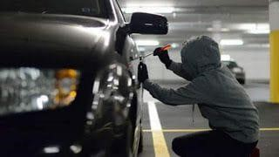

**Figure 2. Vehicle Theft**

## 1.2 Problem Overview

Every human being needs sleep, lack of sleep causes human inactiveness, improper reflex, losing of focus, gets deviated which decreases the capability to make proper decisions which is necessary for driving a vehicle. As per WHO records about 1.25 million of people were injured or dead due to accidents in a year. Some of them neglect the traffic rules, like over speeding, crossing the signals, crossing the lane, also having technical issues with the break’s failure, tires. To mitigate these issues this paper focuses on the solution to reduce the fatal cases by providing a smart drowsiness detection system. This model has an accuracy of 90%. Machine learning, Computer vision are being used in this model which are the subset of AI and it allows the user to train the system and predict the output in a certain range. This technology helps to reduce the gap between human and machines.

## 1.3 Hardware Specification

Processor : Intel Core i3.

RAM : 8 GB RAM

Hard Disk : 100 GB

Web cam / In-built laptop camera

## 1.4 Software Specification

**Anaconda Navigator**: Anaconda navigator is a graphical consumer interface (gui) this is blanketed within the anaconda distribution, permitting you to effortlessly release packages and control conda applications, environments and channels with out the use of commandline commands. Navigator can look for applications in anaconda.Org or the nearby anaconda repository. It's miles to be had for windows, macos and linux.



#### Figure 4: Anaconda home tab

**Jupyter Notebook:** The jupyter notebook expands the console-primarily based approach to interactive computing in an approximate. new route, Dispensing a bendy internetprimarily based application to capture the whole computing method: enlarging, logging and applying code, as well as speaking outcomes. The jupiter pocket book combines two elements:

1. A web application
2. Notebook documents

**Python 3:** Python is the basis of the program that we wrote in the system. It utilizes many of the python libraries.

**Windows/ linux/ Mac OS**

# 2. LITERATURE SURVEY

## 2.1 Existing System

PCA based method which was used earlier for eye/face detection failed as it does not support night driving conditions and has a lower accuracy rate. So to overcome this drawback LBPH algorithm is used The CNN, DNN based technique used for face recognition doesn’t suppport realtime face recognition and also has a lower accuracy rate.

**DRAW BACKS:**

* Few of the models don’t support night driving conditions or glasses,etc. •
* Only few systems support real-time face recognition
* No existing systems including both drowsiness detection system and vehicle security system using face recognition

## 2.2 Proposed System

In this system we’re adding up two different models, that is drowsiness detection and face recognition for safety and security purposes of the driver. First we will be pooping up with the GUI window which has two buttons, one is drowsiness detection and other is face recognition system.

Measure the driver’s safety parameters. Firstly in drowsiness detection model we made an alert system which can alert the driver whenever he feels drowsy for more than 3-4 seconds he’ll be alarmed and can stay awake or take a break. Whereas In the second model, face recognition provides security to our vehicle by detecting the driver’s face and providing access. Thedrowsiness detection system can be implemented in every vehicle such that we can prevent road accidents and decrease the death ratio which are caused due to drowsiness and Theface recognition system is very helpful to maintain the security of the vehicle preventing vehicle thefts.

# 3. PROBLEM FORMULATION

The goal of the project is to detect drowsiness while driving and inform the driver at the appropriate time to avoid any mishaps. The project employs a CNN model to determine whether or not a person is drowsy based on whether or not their eyes are closed or open. The idea has a direct application in the vehicle sector, making driving safer and lowering the number of people killed in car accidents caused by drowsy driving

# 4. OBJECTIVES

The purpose of the drowsiness detection system is to aid in the prevention of accidents passenger and commercial vehicles. The system will detect the early symptoms of drowsiness before the driver has fully lost all attentiveness and warn the driver that they are no longer capable of operating the vehicle safely. This device will not, however, guarantee that the driver will be fully awakened and that an accident will be avoided. It is simply a tool for improving driver safety; focusing primarily on long-haul truck drivers, nighttime drivers, people driving long distances alone or people suffering from sleep deprivation.

# 5. METHODOLOGY

The methodology used to design the Drowsiness Detection System is an iterative research and analysis cycle. The research stage generates concepts and the analysis stage selects concepts, analyze requirements and constraints. The cycle is then repeated to generate more refined concepts and these concepts are further analyzed.

**Requirements**

* Reliability: The solution should reliably detect drowsiness so that it can serve its purpose as a system for promoting driver safety.
* Real-time response: The operation of a vehicle can involve relatively high speeds, a system that cannot detect drowsiness and warn that driver promptly can lead to serious consequences.
* Unobtrusive: It is very important that the solution is as transparent to the driver as possible.
* Economical: Existing solutions to this problem are available today but the effective ones are usually too expensive for widespread implementation.
* Flexible: To be effective, the solution should be designed so as to accommodate for all types of users, in terms of physical attributes.

**Constraints**

* Space: The solution needs to be implemented in a space-efficient manner. It must not interfere with the existing controls of the car.
* Power: There will be a limited power source so the solution needs to designed so that it can operate properly on lim

# 6.EXPERIMENTAL SETUP

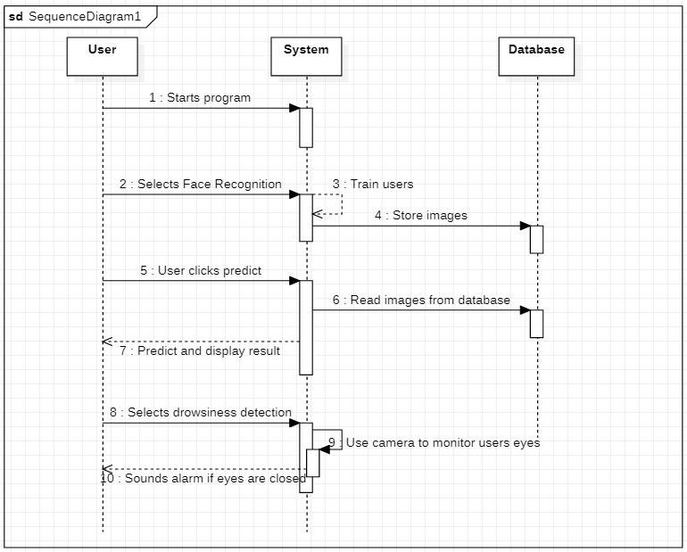

# 7.CONCLUSION

We have measured the driver’s safety parameters. Firstly in drowsiness detection model we made an alert system which can alert the driver whenever he feels drowsy for more than 3-4 seconds he’ll be alarmed and can stay awake or take a break. Whereas In the second model, face recognition provides security to our vehicle by detecting the driver’s face and providing access. Thedrowsiness detection system can be implemented in every vehicle such that we can prevent road accidents and decrease the death ratio which are caused due to drowsiness and Theface recognition system is very helpful to maintain the security of the vehicle preventing vehicle thefts.

As AI techniques are growing vastly, we can make systems more intelligent to understand the requirements of the hour. We can introduce various models and use different types of algorithms to get the best results. Road accidents are common in countries like India. Due to small negligence there’s a huge loss to the lives of the human. By adapting such systems, we can try to control the road accidents and also the security of the vehicle can be maintain by taking the alert and security systems into consideration.

## REFERENCES

1. 1Su, H.,& Zheng, G. (2008). A partial least squares regression-based fusion model for predicting the trend in drowsiness. IEEE Transactions on Systems, Man, and Cybernetics-Part A: Systems and Humans, *38*(5), 1085-1092.
2. Friedrichs, F., & Yang, B. (2010, June). Camera-based drowsiness reference for driver state classification under real driving conditions. In *2010 IEEE Intelligent Vehicles Symposium* (pp. 101-106). IEEE.
3. Flores, M. J., Armingol, J. M., & de la Escalera, A. (2011). Driver drowsiness detection system under infrared illumination for an intelligent vehicle. *IET intelligent transport systems*, *5*(4), 241-251.
4. Zhang, W., Cheng, B., & Lin, Y. (2012). Driver drowsiness recognition based on computer vision technology. *Tsinghua Science and Technology*, *17*(3), 354-362.
5. Mbouna, R. O., Kong, S. G., & Chun, M. G. (2013). Visual analysis of eye state and head pose for driver alertness monitoring. *IEEE transactions on intelligent transportation systems*, *14*(3), 1462-1469.
6. Tadesse, E., Sheng, W., &Liu, M. (2014, May). Driver drowsiness detection through HMM based dynamic modeling. In *2014 IEEE International conference on robotics and automation (ICRA)* (pp. 4003-4008). IEEE.
7. García, F., de la Escalera, A., & Armingol, J. M. (2014). Driver monitoring based on low-cost 3-D sensors. *IEEE Transactions on Intelligent Transportation Systems*, *15*(4), 1855-1860.
8. Babaeian, M., Bhardwaj, N., Esquivel, B., & Mozumdar, M. (2016, November). Real time driver drowsiness detection using a logistic-regression-based machine learning algorithm. In 2016 IEEE Green Energy and Systems Conference (IGSEC) (pp. 1-6). IEEE.
9. Yan, J. J., Kuo, H. H., Lin, Y. F., & Liao, T. L. (2016, July). Real-time driver drowsiness detection system based on PERCLOS and grayscale image processing. In 2016 International Symposium on Computer, Consumer and Control (IS3C) (pp. 243-246). IEEE.
10. Zhao, X., & Wei, C. (2017, August). A real-time face recognition system based on the improved LBPH algorithm. In 2017 IEEE 2nd International Conference on Signal and Image Processing (ICSIP) (pp. 72-76). IEEE.
11. Reddy, B., Kim, Y. H., Yun, S., Seo, C., & Jang, J. (2017). Real-time driver drowsiness detection for embedded system using model compression of deep neural networks. In Proceedings of the IEEE Conference on Computer Vision and Pattern Recognition Workshops (pp. 121-128).
12. Qu, X., Wei, T., Peng, C., & Du, P. (2018, December). A fast face recognition system based on deep learning. In 2018 11th International Symposium on Computational Intelligence and Design (ISCID) (Vol. 1, pp. 289-292). IEEE.
13. Boyko, N., Basystiuk, O., & Shakhovska, N. (2018, August). Performance evaluation and comparison of software for face recognition, based on dlib and opencv library. In 2018 IEEE Second International Conference on Data Stream Mining & Processing (DSMP) (pp. 478-482). IEEE.
14. Kumar, P. M., Gandhi, U., Varatharajan, R., Manogaran, G., Jidhesh, R., & Vadivel, T. (2019). Intelligent face recognition and navigation system using neural learning for smart security in Internet of Things. Cluster Computing, 22(4), 7733-7744.
15. Mehta, S., Mishra, P., Bhatt, A. J., & Agarwal, P. (2019, November). AD3S: Advanced Driver Drowsiness Detection System using Machine Learning. In 2019 Fifth International Conference on Image Information Processing (ICIIP) (pp. 108- 113). IEEE.
16. Kassim, A. M., Jaya, A. K. R. A., Azahar, A. H., Jaafar, H. I., Sivarao, S., Jafar,

F. A., & Aras, M. S. M. (2019). Performance analysis of acceleration sensor for movement detection in vehicle security system. Int J Adv Comput Sci Appl, 10(10), 395-401

1. Deng, W., & Wu, R. (2019). Real-time driver-drowsiness detection system using facial features. IEEE Access, 7, 118727-118738.
2. Xing, T., Wang, Q., Wu, C. Q., Xi, W., & Chen, X. (2020). dWatch: A Reliable and Low-Power Drowsiness Detection System for Drivers Based on Mobile Devices. ACM Transactions on Sensor Networks (TOSN), 16(4), 1-22.
3. Jabbar, R., Shinoy, M., Kharbeche, M., Al-Khalifa, K., Krichen, M., & Barkaoui,

K. (2020, February). Driver drowsiness detection model using convolutional neural networks techniques for android application. In 2020 IEEE International Conference on Informatics, IoT, and Enabling Technologies (ICIoT) (pp. 237- 242). IEEE.

1. Bohara, S. (2020). Artificial Intelligence and Machine Learning: Face Detection and Recognition with Python.
2. Pati, B. (2020). ISS: Intelligent Security System Using Facial Recognition. PROGRESS IN ADVANCED COMPUTING AND INTELLIGENT ENGINEERING, 96.
3. Dua, M., Singla, R., Raj, S., & Jangra, A. (2021). Deep CNN models-based ensemble approach to driver drowsiness detection. Neural Computing and Applications, 33(8), 3155-3168.